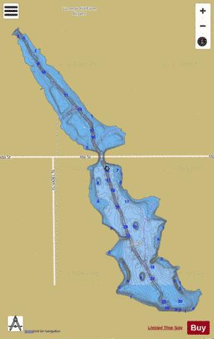Flanagan Lake Directions

Ida St.

168th Street

Fort St.

BC

AC

Boat Ramp is at “A” on the map.

**There is no sign for the lake on 168th Street or on Ida Street.**

* North of **Fort St** on **168th St.**
* First turn north of Fort on the left (west) is **Hartman**
* Right turn (only option) at **169th St.**
* Left turn on **Himebaugh** (first intersection)
* Straight across **H.W.S. Cleveland St**. to enter parking area for boat ramp. There is a sign for Flanagan Lake to the right of the entrance, but the lake is straight ahead, so it’s obvious by then.
* Overflow parking is on Cleveland.
* There is a **picnic shelter** at the far end of the parking lot and we will rendezvous there. We will use our pop-ups for additional shaded space if necessary.
* There is a pair of rest rooms at that parking area.

Kayak kiosk is at the ramp end of the parking lot. Rental times start at 11, 1, and 3, so our “group launch” may be closer to 3 than 2:30 to accommodate anyone renting a kayak.

IF THERE IS A CROWD (or we get bored, or…) we may move our picnic base to the other picnic/playground area marked ‘**B**” on the map**. That picnic area is the first “real” left (south) turn west of 168th Street on Ida,** shortly before (east of) the bridge crossing the lake. There is no sign identifying it as Flanagan Lake. There is a picnic shelter and set of rest rooms there.

Omaha Parks and Recreation asked us to start our clean-up at the Boat Ramp, so it will take a large crowd to make us shift our “base” before 4 or 4:30 PM. We may stay by the boat ramp the entire time.

Judy’s cell may or may not have a signal out there (and I may or may not hear/feel it), 402-650-7536.